78GIIN – Writing Skills for Engineering
Research Paper
Traffic Management System
Gagliardo Miguel Angel
24 de Enero de 2025
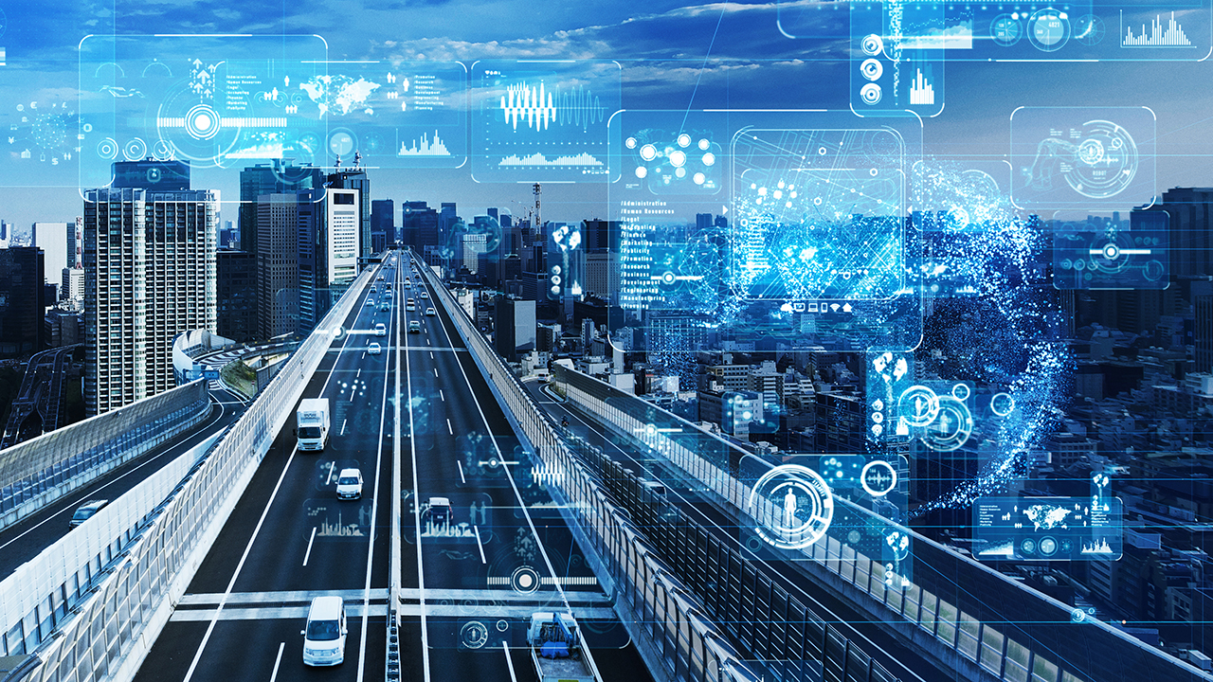
Abstract
The project aims to develop an intelligent system for urban traffic management by utilizing technologies like Artificial Intelligence (AI), the Internet of Things (IoT), and real-time data analytics. This system is designed to optimize traffic flow, cut down on travel times, and reduce pollution in urban areas. The implementation of smart sensors and cameras, along with AI algorithms, will enable efficient and proactive real-time traffic management. Additionally, the integration with mobile applications and information panels will enhance communication with drivers and pedestrians.

Table of Contents
Abstract...…….….…..……………………………………………………………………………... 2
Introduction….……………………………………………………………………………………… 5
Justification….……………………………………………………………………………………… 6
Project Development
3.1. Requirements Analysis ….…………………………………………………………………. 4
3.2. System Design………..…………..………………………………………………………….... 5
3.3. Technologies ...….…………………………………………………………………………..…. 6
3.4. Systems Integration ……………………………………………………………………….….. 7
3.5. Testing and Validation …………………………………………………………………...….... 8
Conclusions and Recommendations .…………………………………………………………..….. 9
References ...………………………………………………………………………..…………………. 10

List of Figures
- Figure 1: Traffic management system diagram.
- Figure 2: Schematic diagram of an urban traffic control system.
- Figure 3: Location of sensors in the city.

List of Tables
- Table 1: Estimated project costs.
- Table 2: Expected results and success metrics.

Introduction
In big cities, traffic congestion is one of the biggest issues affecting the quality of life for residents and the environment. This project aims to develop an intelligent urban traffic management system to improve traffic flow, cut down on travel times, and reduce pollution. By utilizing technologies like AI and IoT, the proposed system seeks to provide creative solutions for real-time traffic management. Additionally, the project will integrate mobile applications to provide real-time information to drivers and pedestrians, improving communication and response to traffic conditions.

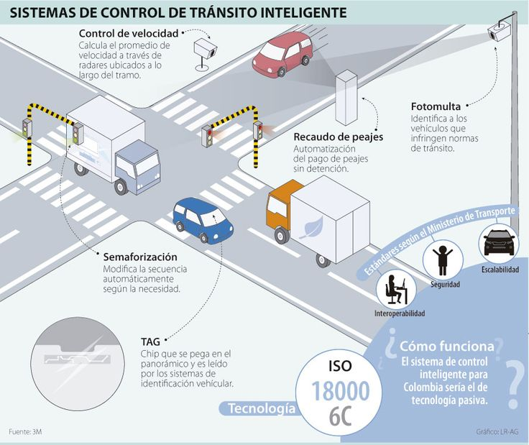

Fig 1: Traffic management system diagram
Justification
The increasing urbanization has caused a major rise in vehicular traffic, leading to congestion, pollution, and accidents. It’s crucial to implement an intelligent traffic management system to tackle these issues. The project is relevant because of its potential to improve urban mobility, reduce pollution, and increase road safety through the use of advanced technologies and real-time data analysis. The ability to predict and manage traffic congestion will not only improve daily travel efficiency but also contribute to a cleaner and safer environment.

Project Development
3.1. Requirements Analysis
The first step in creating the system is identifying the necessary requirements. This means figuring out the most congested areas and critical traffic points, as well as peak vehicle flow times. Additionally, the types of data to be collected and the technologies required for obtaining and processing them must be defined. We’ll conduct detailed traffic studies to understand both current and future patterns, and consultations with local authorities and residents will provide a complete view of traffic problems and potential solutions.

3.2. System Design
The system design involves creating a detailed plan showing how the various technologies will be integrated. This includes strategically placing sensors and cameras, as well as setting up the required communication infrastructure and software to process and analyze the data. The system will be designed to be scalable, allowing for the addition of new technologies and expansion to other areas of the city in the future. Integration with other transport systems, such as public transport, will also be considered to create a holistic and coordinated approach to traffic management.

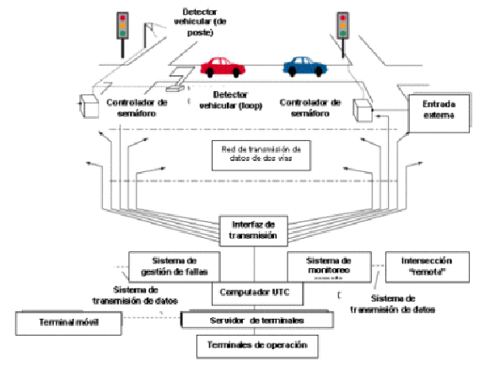
Fig 2: Schematic diagram of an urban traffic control system

3.3. Technology Implementation
To collect data, traffic sensors and smart cameras will be installed at key points in the city. These devices will collect real-time information about vehicle flow, speed, and traffic density. The data will be sent to a control center where AI algorithms will process it to identify patterns and predict congestion. Different types of sensors, including proximity sensors, speed sensors, and license plate recognition cameras, will be used to provide a comprehensive view of traffic conditions. Additionally, IoT devices will be implemented to enable communication between the sensors and the central system.

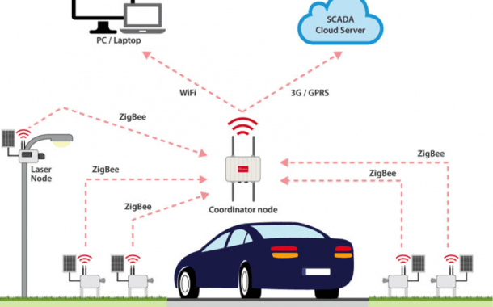
Fig 3: Location of sensors in the city

3.4. System Integration
System integration means linking the sensors and cameras to the traffic management platform. This will allow real-time monitoring and automatic decision-making to adjust traffic lights, divert traffic, and provide information to drivers through mobile applications and information panels. We’ll develop an easy-to-use interface for control center operators, enabling them to efficiently monitor and manage traffic. Security protocols will also be implemented to protect the collected data and ensure user privacy.

3.5. Testing and Validations
We’ll run thorough tests to make sure the system works properly. This will include simulating different traffic scenarios and evaluating the accuracy of AI algorithms in predicting and managing traffic. We’ll validate it by comparing the results to the success metrics. Historical data will be used to create test models, and controlled environment tests will be conducted before full implementation in the city. Additionally, feedback from users and operators will be gathered to identify areas for improvement and adjust the system accordingly.

Conclusions and Recommendations
The development of an intelligent urban traffic management system offers multiple benefits, including optimizing vehicle flow, reducing travel times, and decreasing pollution. We recommend implementing the system gradually, starting with pilot areas, and continuously evaluating and adjusting the algorithms and technological infrastructure. Working with local authorities and integrating with other transport systems will be key to success. In the long term, we suggest exploring the incorporation of emerging technologies and expanding the system to other cities and regions to maximize its positive impact.

References
- Singh, A., & Jena, D. (2020). Leveraging Artificial Intelligence for Traffic Management: A Conceptual Framework. Journal of Urban Technology, 27(3), 45-59.
- Chen, S., & Lin, C. (2019). Intelligent Transportation Systems: A Comprehensive Review. IEEE Transactions on Intelligent Transportation Systems, 20(9), 3525-3549.
- Breja, A., & Naik, N. (2018). Application of Sensor Technologies in Traffic Management: A Comprehensive Review. Proceedings of the 2018 International Conference on Advances in Electronics, Computers and Communications (ICAECC), 1-6.
- Kulkarni, A., Gavade, A., & Patil, V. (2020). Applications of Artificial Intelligence in Traffic Management: A Review. International Journal of Advanced Research in Computer Engineering & Technology, 9(2), 521-532.

Appendix
I Estimated project costs
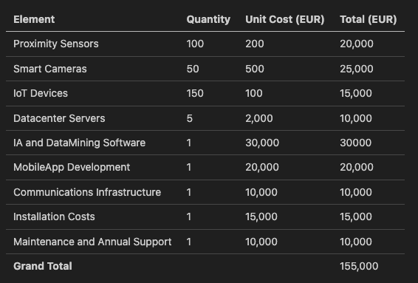

II Expected results and success metrics
